**EXPENSE TRACKER**

**PROJECT SYNOPSIS**

OF MINOR PROJECT

**BACHELOR OF TECHNOLOGY**

Computer Science and Engineering

SUBMITTED BY

Samridhi Sharma (2203551)

Sapna Maurya (2203557)

Shafneet Kaur (2203560)

Batch: 2022-2026



**GURU NANAK DEV ENGINEERING COLLEGE**,

**LUDHIANA**

**TABLE OF CONTENTS**

|  |  |
| --- | --- |
| **Content** | **Page No.** |
| Introduction | 1 |
| Rationale | 2 |
| Objectives | 3 |
| Literature Review | 4 |
| Feasibility Study | 5 |
| Methodology | 6-7 |
| Facilities required for proposed work | 8 |
| Expected outcomes | 9 |
| References | 10 |

**INTRODUCTION**

Rightly said “Financial health hinges on understanding where your money goes.” In today's fast-paced world, keeping track of expenses can be a daunting task. From daily coffee runs to unexpected bills, our finances often feel like a chaotic puzzle and thus managing personal finances effectively is crucial for achieving financial stability and achieving your goals.

By meticulously recording every expenditure, we gain insights into areas of overspending, enabling you to be more informed about our expenditure. Incorporating expense tracking into your financial routine can gain a better understanding of your spending habits, make informed financial decisions, and ultimately improve your overall financial health.

This project "Expense Tracker" will be a user-friendly application designed to empower individuals to take control of their finances. This Expense Tracker aims to make personal finance management easily accessible anywhere at any time just at the verge of your clicks.

The application will empower individuals to gain a clear understanding of their spending habits, identify areas for improvement, and ultimately achieve their financial goals. By seamlessly integrating data entry, visualization, and insightful reporting, the Expense Tracker will provide users with a powerful tool to take control of their finances.

**RATIONALE**

This project, an **Expense Tracker**, is crucial for several reasons. Today, financial management is more important than ever. However, we often struggle to understand where our money goes, leading to overspending, accumulating debt, and failing to achieve financial goals. This lack of financial awareness can create significant stress and hinder overall well-being.

The Expense Tracker aims to address this critical need by providing a user-friendly platform for everyone to gain control of their finances. This empowers individuals to create and stick to budgets, reduce unnecessary expenses, and prioritize saving for important goals, such as retirement, education, or a down payment on a home. Ultimately, this project will contribute to improved financial health, reduced stress, and increased financial security for users. Thus, Expense Tracker is not just a tool, it's an enabler.

**OBJECTIVES**

1. To create a functional and user-friendly GUI application to track expenses on individual level and at large scale (i.e. for a company).
2. To analyze expenses using Machine Learning and generate detailed reports, identify spending patterns and offer actionable insights for better financial management.
3. To implement AI-powered suggestions and alerts when users exceed their budget.

**LITERATURE REVIEW**

Expense Tracker ensures security, insights, wish-lists, & reminders for seamless management.

**Implementation for the Web Platform**

**Frontend Development:**

**HTML:** For structuring the application’s content and layout.

**CSS:** For styling the application, ensuring an appealing and user-friendly interface.

**React:** For building a dynamic, responsive, and interactive user interface.

**Backend Development:**

**Python (Flask/Django):** For handling server-side logic, APIs, and backend functionality.

**Database:**

**SQL:** To manage data storage: user information, expenses, income, wish lists, and reports.

**Client-Side Logic:**

**JavaScript**: To add dynamic features: real-time updates, interactive charts, and form validation.

*Table 1.1: Comparison of Features in Expense Management Apps*

|  |  |  |  |
| --- | --- | --- | --- |
| **Feature** | **Expense Manager (Bishinews)** | **Hello Expense (Alan L)** | **Expense Tracker (ET)** |
| Ease of Use | Medium | Low | High |
| Backup/Restore | Yes | Yes | Yes |
| Expense/Income Tracking | Yes | Yes | Yes |
| Wish List | No | No | Yes |
| Decision Making Tool | No | No | Yes |
| Notifications | Yes | No | Yes |
| Password Protection | No | No | Yes |
| Graphical Reports | No | No | Yes |

**FEASIBILITY STUDY**

The feasibility study evaluates the practicality & significance of developing an Expense Tracker.

1. **a. Technical Feasibility**

* **Technology Stack:** Utilizes modern and scalable tools like React, Python, SQL, HTML, and CSS for reliability.
* **Development Tools**: React for an interactive frontend and Flask/Django for a robust backend.
* **Resources:** Requires skilled developers and affordable hosting services.
* **Challenges:** Securing data and optimizing performance for graphical reports and notifications, mitigated with robust development practices.

**b. Operational Feasibility**

* **Ease of Use:** Intuitive design to accommodate users with varying technical expertise.
* **Target Audience:** Individuals and small businesses seeking efficient expense management.
* **Integration:** Features calendar notifications and third-party authentication for better usability

**c. Economic Feasibility**

* **Development Costs:** Low, leveraging open-source tools and affordable hosting**.**
* **Revenue Model:** Free version with ads and premium subscriptions for advanced features like analytics and backup.
* **Market Demand:** Increasing demand for financial tools ensures the app’s viability.

**2. Need and Significance**

* **Need:** Fills the gap in existing tools by offering a balance of simplicity, security, and functionality.
* **Significance:** Helps users manage expenses, make informed decisions, track progress through notifications and insights, promoting financial discipline and goal achievement.

**METHODOLOGY**

1. Phase 1: Requirement Gathering

* Define key features (expense tracking, notifications, graphical reports).

2. Phase 2: System Design

* Design an intuitive UI using React.
* Develop a secure backend using Flask/Django.

3. Phase 3: Development

* Build the frontend and backend.
* Design the database using SQL.

4. Phase 4: Testing

* Perform unit, integration, and user acceptance testing to ensure reliability.

5. Phase 5: Deployment

* Deploy on a cloud platform (AWS, Azure, or Firebase) for scalability and security.

### 6. Phase 6: Post-Deployment Monitoring & Feedback

* Gather feedback from users to identify any issues, areas of improvement, and additional feature requests.

### 7. Phase 7: Maintenance

* Update the application with new features, bug fixes, and security patches based on user feedback and emerging needs.

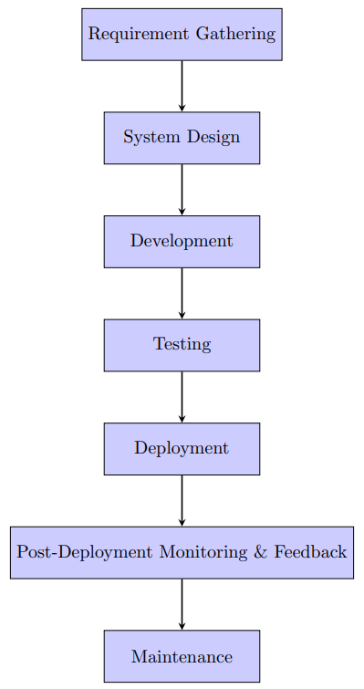

Figure 1.1: Methodology

**FACILITIES REQUIRED FOR PROPOSED WORK**

Facilities required for minor project on Expense Tracker include essential software and hardware components to ensure seamless development and deployment of the project. On the software front, **GitHub** serves as the primary platform for version control and collaboration, complemented by **GitHub Desktop** for ease of repository management. **VS Code** is utilized as the integrated development environment for writing and debugging code, while the **Command Prompt (Cmd)** supports essential command-line operations. Additionally, **Netlify** facilitates the hosting and deployment of the project. The hardware requirements include a reliable **laptop** with sufficient processing power and storage to handle development tasks efficiently, along with a stable **internet connection** to enable online collaboration, access to resources, and deployment activities. These facilities collectively ensure a robust foundation for successful project execution.

**EXPECTED OUTCOMES**

The expected outcomes of the **Expense Tracker** project include the development of a **reliable and efficient tool for managing finances at both individual and group levels**. Users will be able to seamlessly **track their income and expenditures**, **categorize transactions**, and **generate detailed reports** for better financial insights. At the group level, the application will facilitate **shared expense management**, enabling **collaborative tracking for activities like trips, events, or household budgets**. This project aims to **simplify financial management**, **promote transparency in group expenses**, and **empower users with data-driven decision-making capabilities** for improved budgeting and savings.

**REFERENCES**

[1] Google, "Google Search," Google. [Online]. Available: <https://www.google.com>. [Accessed: Jan. 21, 2025].

[2] W3Schools, "HTML, CSS, JavaScript Tutorials," W3Schools. [Online]. Available: <https://www.w3schools.com/>. [Accessed: Jan. 21, 2025].

[3] React, "React: A JavaScript library for building user interfaces," React. [Online]. Available: <https://reactjs.org/>. [Accessed: Jan. 21, 2025].

[4] Django, "Django: The web framework for perfectionists with deadlines," Django. [Online]. Available: <https://www.djangoproject.com/>. [Accessed: Jan. 21, 2025].

[5] Stack Overflow, "Developer Community," Stack Overflow. [Online]. Available: <https://stackoverflow.com/>. [Accessed: Jan. 21, 2025].

[6] GitHub, "GitHub: Where the world builds software," GitHub. [Online]. Available: <https://github.com/>. [Accessed: Jan. 21, 2025].

[7] Netlify, "Netlify Documentation," Netlify. [Online]. Available: <https://www.netlify.com/docs/>. [Accessed: Jan. 21, 2025].